**Group final project**

Group2

topic

contents

1. Executive Summary 3

1.1 Project Overview 3

1.2 Relevant Theories/Models 3

2. Introduction 3

2.1 Background of the Study 3

2.2 Motivation of the Research 4

2.3 Scope of the Report 4

3. Methodology 5

3.1 Research Design 5

3.2 Data Collection Methods 5

3.3 Data Analysis Techniques 5

3.3.1 Taking logarithms 5

3.3.2 First Difference 5

3.3.3. Stock index analysis 6

4. Forecast and Analysis 15

4.1 forecast for three stock indexs 15

4.1.1 NASDAQ 15

4.1.2.DJI 26

4.1.3.SPX500 31

4.2. The analysis of the Time Window 38

4.2.1.   Impact of Time Window Length on Forecasting 39

4.2.2.   Impact of Time Window Length on Forecasting 43

4.2.3. Impact of Averaging 46

5. Discussion 50

5.1 Interpretation of Findings 50

5.2 Comparison of the ETS Model and ARIMA Model 50

6. Recommendations 50

7. Conclusion 50

Reference 51

Appendices 52

Code_1 52

Code_2 52

# 1. Executive Summary

## 1.1 Project Overview

This report embarks on an insightful journey into the world of stock indices through the application of time series analysis, particularly leveraging the ARIMA (AutoRegressive Integrated Moving Average) and ETS (Exponential Smoothing) models.

The analysis of stock indices via time series methods provides a comprehensive understanding of market behaviors, highlighting trends, seasonal variations, and potential future movements. The goal of this report is to utilize these sophisticated statistical models to extract meaningful information from historical stock index data, enhancing predictive accuracy and informing strategic decision-making.

The ARIMA model, with its robust handling of autoregressive and moving average components, and the ETS model, with its ability to address error, trend, and seasonality components, together form a comprehensive approach. We will meticulously analyze the stock index data using these models, aiming to interpret the findings within the context of today’s dynamic financial landscape.

The insights derived from this analysis are expected to empower investors, researchers, and market analysts with a deeper understanding of the stock index’s past behavior and its implications for future performance.

## 1.2 Relevant Theories/Models

ETS Model / ARIMA Model/ Testing Estimated Residuals

# 2. Introduction

## 2.1 Background of the Study

The global financial markets have evolved significantly in recent decades, becoming increasingly interconnected and complex. One of the world’s most influential economy, the United States, has been at the forefront of this transformation. Its respective stock indices, including NASDAQ, DJIA, and SPX 500, have a profound impact on both domestic and global market dynamics.

Understanding these indices’ behaviors is crucial for investors, policymakers, and researchers, as these indices often serve as a sign of the broader economic health of the US and even the whole market. Traditional analysis methods can be valuable, but they often fail to predict future trends effectively due to the inherently dynamic and non-linear nature of financial markets. This needs the adoption of more sophisticated analytical methods. One such method is time series analysis, which takes into account temporal dependencies and fluctuations in the data over time, providing a deeper understanding of patterns and predictive insights. This report aims to apply time series analysis to the study of the United States stock indices, with an aim to unravel their underlying patterns, dependencies, and possibly forecast future movements.

## 2.2 Motivation of the Research

In the ever-evolving world of finance, investors are always on the lookout for information that will give them an edge. As Warren Buffet famously said, "Risk comes from not knowing what you're doing." In this context, understanding the dynamics of stock indices becomes critical. A stock index reflects the performance of a group of shares and is often seen as a barometer of the economy's health. Analyzing stock indices gives a comprehensive overview of market trends, investor sentiment, and potential investment opportunities.

Given the dynamic and often volatile nature of financial markets, regular and detailed analysis of key stock indices is paramount. It helps investors make informed decisions, from choosing the right time to invest to selecting which sectors have the most promising outlooks. The more data we can harness, and the better our understanding of the market trends, the more equipped we are to anticipate future movements and take appropriate action. In an era where data is the new oil, we believe that the insights gleaned from this analysis could prove invaluable, ultimately contributing to robust financial strategies and, potentially, more stable and prosperous economies.

## 2.3 Scope of the Report

This report is focused on using time series analysis to examine the fluctuations and trends in the stock indices of the United States for 20 years, from 1999 to 2019. And to do the forecasting, we just use data for 5 years, from 2012 to 2017. Our study centers on stock market of the United States, represented by three main stock indices, the NASDAQ index and Dow Jones Industrial Average, and SPX 500. To conduct this analysis, we will use both primary data (derived from the actual historical performances of the indices) and secondary data (sourced from relevant financial and economic literature and reports). This study will specifically scrutinize broad market trends and patterns but will not delve into the performance of individual stocks or specific sectors within these markets. Potential limitations of this report include the unpredictable nature of the stock markets and the numerous external factors that can impact them, such as political events, policy changes, and global economic trends. Additionally, while our time series analysis can highlight patterns and suggest correlations, it is not intended to predict future performances of the indices.

# 3. Methodology

## 3.1 Research Design

## 3.2 Data Collection Methods

## 3.3 Data Analysis Techniques

In this study, we mainly use the ARIMA model and ETS model. Before performing the model fitting, we need to confirm that the data are stationary, which is the assumed premise of the ARIMA model. We assume that a time series is stationary when its mean, variance, and autocorrelation structure are zero.

### 3.3.1 Taking logarithms

we need to find the white noise component before we can fit the model. However, the stock price is not white noise because there is no stable expectation, no constant variance, and it is very highly correlated with residuals. We have to take the logarithm of the stock price. If you take the natural logarithm of asset returns, the resulting distribution follows a normal distribution. At the same time the asset price return is very much like white noise. It follows both a normal distribution, residual expectation, and variance is basically zero. Occasionally, with a black swan incidents, the fluctuations can be large, but the basic range is between plus and minus 0.1. So, we consider it a smooth observable variable.

### 3.3.2 First Difference

We treat the data with a first order difference to try to make the time series stationary. The first order difference is equal to the difference between the closing price of the day and the opening price of the day. It can be viewed as the change in price over the course of the day. The purpose of this is to try to eliminate any trends in the data so that the new series has a constant mean and variance. In other words, the original price series is increasing over time. However, the difference in prices may not have a trend and we can obtain a constant variance.

### 3.3.3. Stock index analysis

#### 3.3.3.1. NASDAQ

First, we examined the NASDAQ time series. Each lags are well beyond the critical value in ACF plot, and they are all with a slow steady downward trend. Moreover, it shows significant autocorrelations at higher lags, it could be an indication of seasonality. Autocorrelation at all lags are out of the critical value, and the PACF plot shows significant partial autocorrelations at the first few lags, thus, we do not think it is a white noise here. Futhermore, residuals shows a significant upward trend. We infer that it is not white noise because its mean is not close to zero like a normal distribution, and it also has a clear pattern and trend. Last, we can find that the the points in Normal Q-Q are along the line, which means the data is normally distributed.

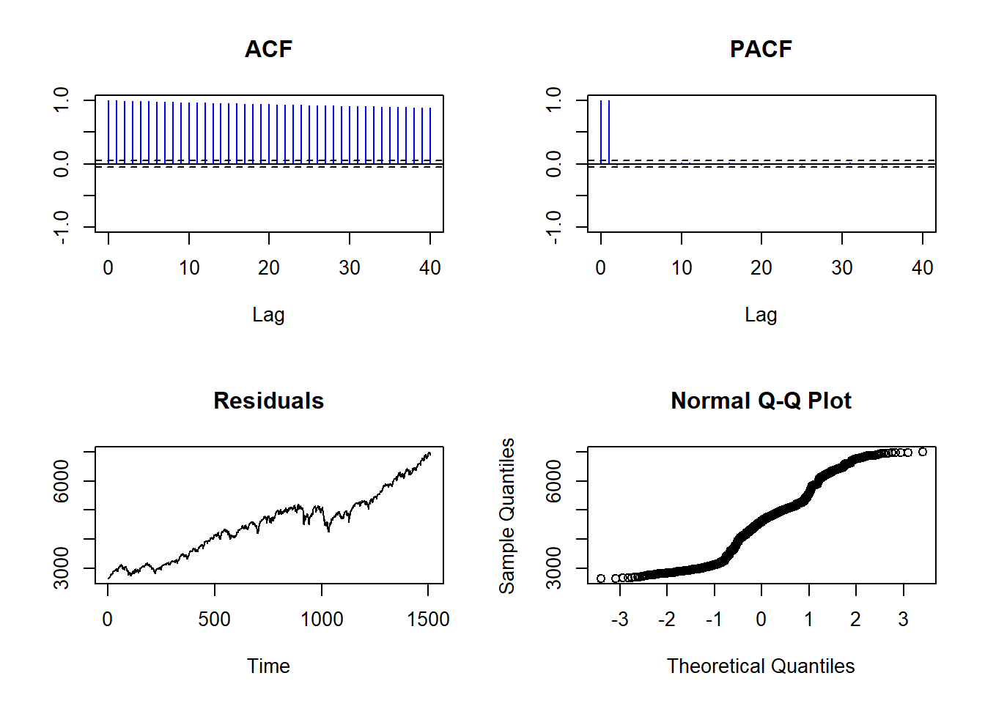

From the characteristics of the log data, we can find that the residuals fluctuated around zero and had its first, then it continued to rise again, and it has been maintaining an upward trend. Although it has some fluctuations with the increase of time, from which we do not see cyclical or regular fluctuations. It can be seen that the values of each lag in the ACF are very close to 1, they are well above the critical value, and these values are slowly decreasing. This indicates that they have strong autocorrelation and can be initially judged as non-white noise. From the PACF plot, lag1 and lag2 are both approximately equal to 1, also indicating that they have strong autocorrelation. From the results of the Normal Q-Q Plot, the points are all very close to the 45-degree line, and it can be assumed that it is normally distributed.

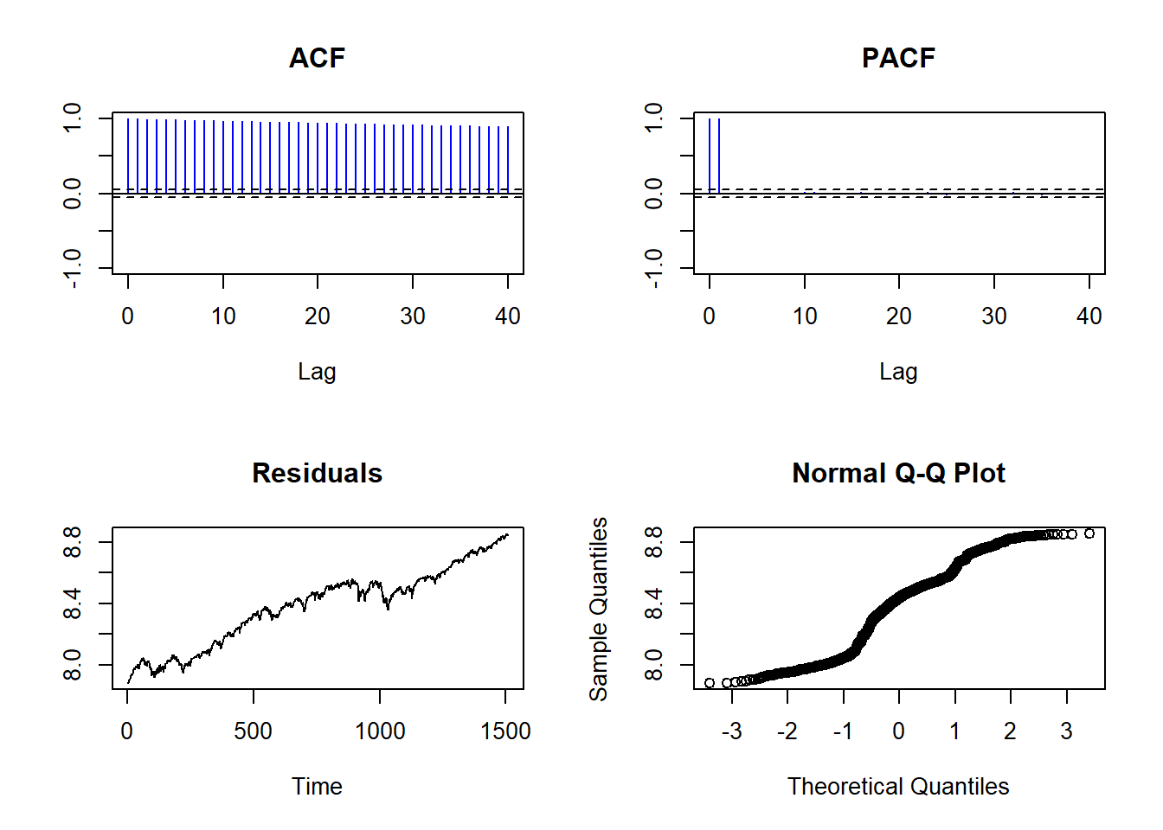

As a result, we chose to switch to another model and take the logarithm of this time series by performing a first-order difference on it. From the characteristics of the logdiff results: we find that the residuals fluctuated around between ±0.02. The mean of residuals is approximately equal to zero, but its variance closes to 7.961067e-05, this suggesting that while it fluctuates slightly around zero. ACF and PACF show that all lags are within the critical values, which indicates that they are not autocorrelated and perform well. From the results of the Normal Q-Q Plot, the points are all very close to the 45-degree line, and it can be assumed that it is normally distributed.

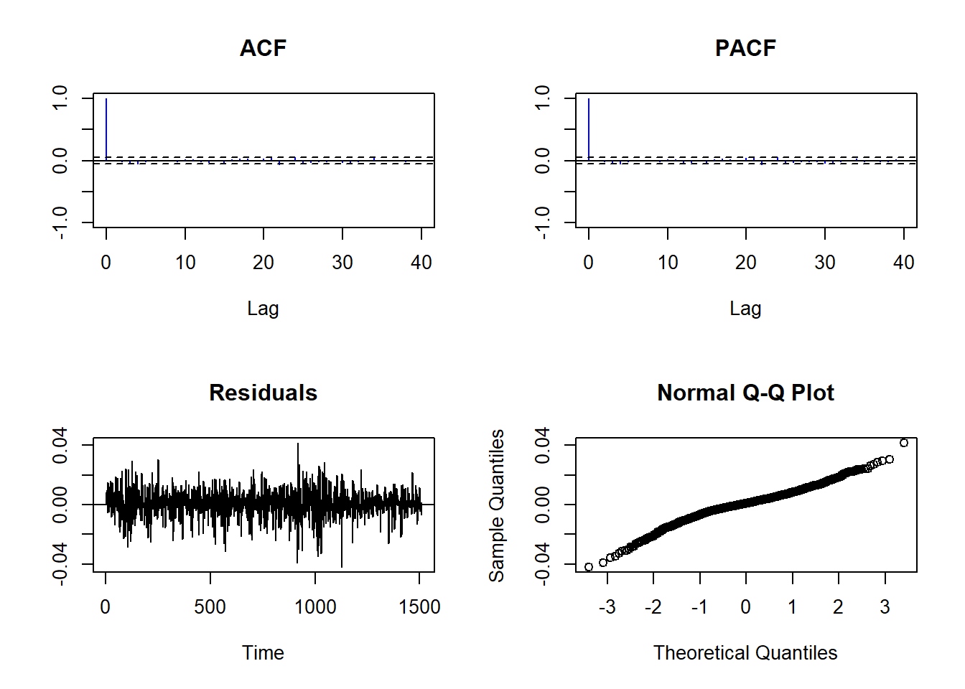

#### 3.3.3.2 DJI

The time series analysis and forecasting process for DJIA index data is as follows:

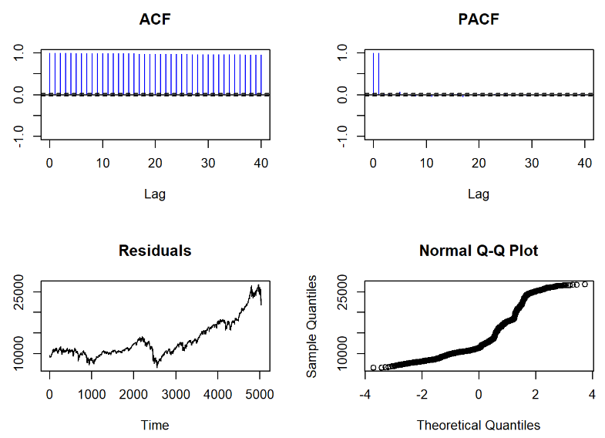

Each lag exceeds the critical value of the ACF, and a slow and steady declining trend is evident. Additionally, significant autocorrelation is observed at higher lags, which may indicate seasonality or periodicity. Since all lags exhibit autocorrelation beyond the critical value, it is concluded that this is not white noise. Furthermore, the residuals show a significant upward trend, reaching a pronounced peak around time 4800 and exceeding 25000. Additionally, the residuals reach a minimum around 2500, with a value of approximately 5000. This may be due to some black swan events. It is inferred that it is not white noise because its mean does not approach zero like a normal distribution, the variance is not constant, and it exhibits a certain upward trend with minor fluctuations. Finally, it can be observed that the points in the normal Q-Q plot nearly align along a straight line, indicating that the data follows a normal distribution.

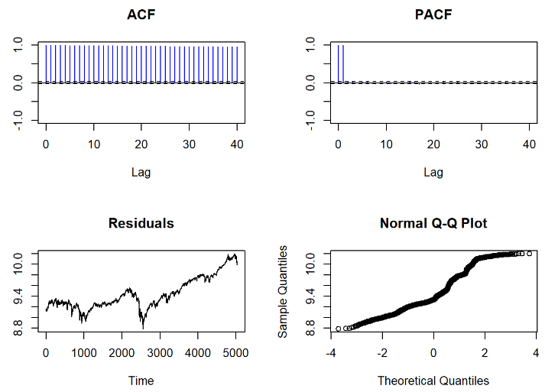

From the characteristics of the dji.log data, it can be seen that there is a sharp cliff-like decline around time 2500, with values dropping below 9, followed by a continued upward trend with fluctuations. However, we did not observe periodic or regular fluctuations. The residuals reach a peak around 4800, reaching a peak value of 10.0. Then, the values of each lag in the ACF are very close to 1, far exceeding the critical value, indicating strong autocorrelation, and we conclude that it is non-white noise. From the results of the normal Q-Q plot, these points are very close to a diagonal line at a 45-degree angle, and we can assume it follows a normal distribution.

we chose to switch to another model and take the logarithm of this time series by performing a first-order difference on it.

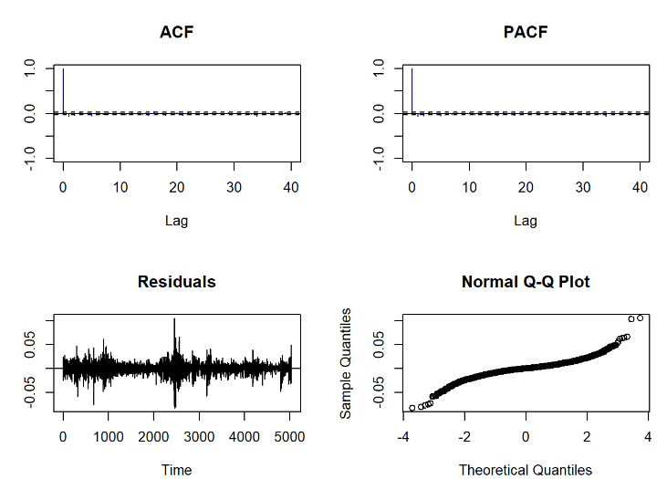

Based on the characteristics of the first-order differenced data: ACF and PACF show significant cutoffs after lag 1, indicating that the first-order differencing has successfully removed strong autocorrelation and linear trends in the data. Additionally, we observe that the residuals fluctuate around zero and have a relatively constant variance (except for events like the black swan event at time 2500). Furthermore, the residuals now exhibit a relatively straight line in the Normal Q-Q plot, indicating approximate normality. Based on these analyses, the differenced data has achieved stationarity, and thus, it is ready for subsequent time series predictions.

#### 3.3.3.3. SPX

From 1999 to 2019, the SPX500 index has experienced many unstable periods. And from 2012 to 2017, we can use these 5 years to do the forecasting. Through the analysis of past data, predicting the future trend and market conditions of the SPX500 index will provide an important judgment for the future development direction of the whole US stock market.

Firstly, we need to process the raw data efficiently. If we test the original data directly, we find that it is not a good object for analysis. As shown in the graphs below, since the ACF does not show a gradual decline and the PACF also does not have a sharp cutoff after lag, differencing may be necessary, and the data might not be stationary here. In addition, the residuals show a clear trend, so it indicates that the model has not fully captured the underlying structure, and differencing might be necessary. In the Normal Q-Q plot, the residuals also depart significantly from the reference line, which indicates the non-normality in the residuals. So differencing can help to improve the modeling process here.

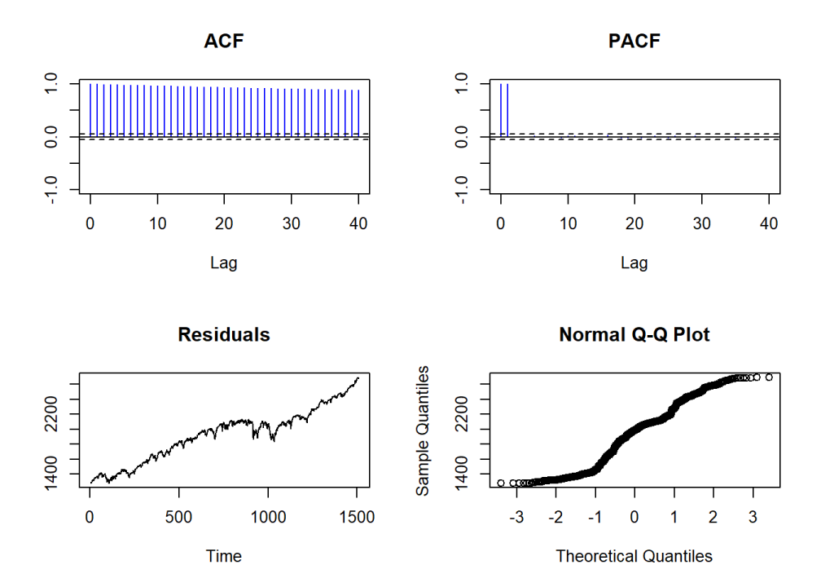

After applying one-time differencing operation here, from the graph below, we can see that the autocorrelation values in ACF drop quickly and the partial autocorrelation in PACF shows a sharp cutoff after lag 1, it suggests that one-time differencing has successfully removed any linear trends in the data. In the Normal Q-Q plot, the residuals follow a relatively straight line, indicating approximate normality. However, the residual plot still shows some unstable patterns, although it looks much more random than before.

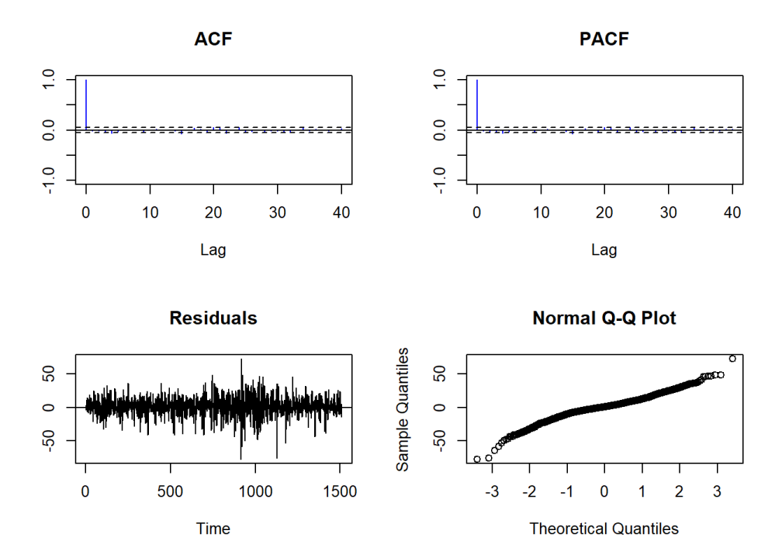

To make the data more stable and feasible, we choose to do the logrithm transformation the original data. However, only operating log transformation of the original data is still not enough, because after the test, the same problems as the original data will appear, including ACF, PACF pattern does not meet the prediction assumptions requirements, and residuals problems exist. The test results are shown in the figures below.

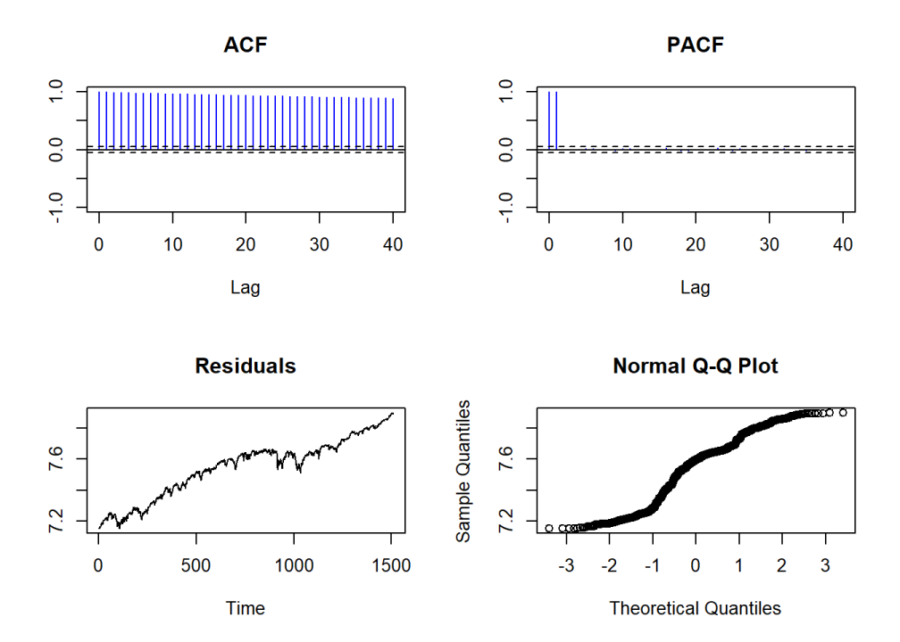

Therefore, we applied one-time differencing operation again on the data with logrithm transformation. The results in the figures below show the feasibility of the processed data. To be more specific, both ACF and PACF show a sharp cutoff after lag 1, suggesting that the one-time differencing has successfully removed any linear trends in the data. Also, the residuals look almost random and relatively stable. And the residuals now follow a relatively straight line in the Normal Q-Q plot, indicating approximate normality of it. Based on these analysis, the differenced data has achieved stationarity, so the data has been already prepared to make subsequent time series predictions.

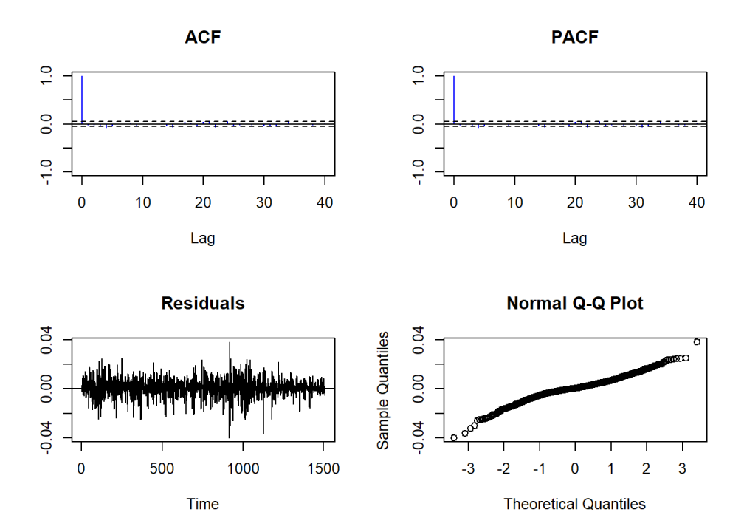

The first time series model we used here is ARIMA model. Firstly, in order to test the effect of the prediction, we divided the data into training set and test set. Here, we choose 80% of the data as the training set and the rest 20% to be the test set, as shown in the figure below.

# 4. Forecast and Analysis

## 4.1 forecast for three stock indexs

### 4.1.1 NASDAQ

We compare the fit of NASDAQ in ARIMA and ETS models and finally pick a fit model for it.

#### 4.1.1.1 ARIMA Model fitting results and analyses:

We plot the train, test and forecast curves in the same graph so that we can more clearly see the gap between the predicted and test values.

Overall, the time series shows a very clear upward trend from 2012 to 2015. autoarima helped us pick out ARIMA (2, 1, 1) as our fitted model. As you can see from the graph, after 2017, FORECAST results in a continuous increase in the stock price over time, and the angle of this diagonal line is roughly 45 degrees. When compared to the test results, both the predicted and test values are inside the confidence interval and the trend is consistent. Only the actual test value has a slight fluctuation and a steeper growth slope. To be precise, this prediction result is very reasonable and satisfactory to us.

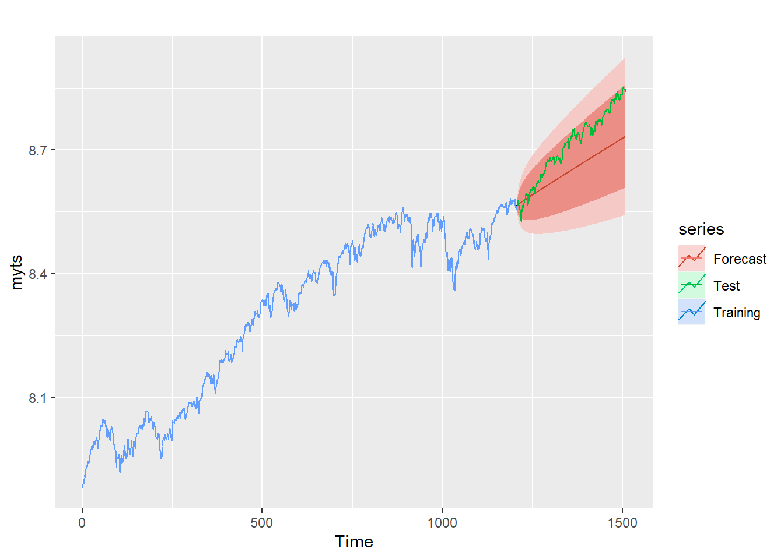

From the results of residuals, it can be seen that the residuals are similar to the form of white noise. There are several reasons for this: firstly, from the histogram, it can be seen that it highly overlaps with the normal distribution curve, so we can understand that it looks to follow a normal distribution. Secondly, most of the lag values detected by ACF are inside the critical value, which is clearly no autocorrelation. In terms of the distribution of the overall residuals (ARIMA(2,1,1)), it tends to be around ±0.025, with one or two occasional deviations far from zero.

Statistically, the Ljung-Box test shows that the Q-value is 6.5888 and the p-value is 0.4729 which is greater than the commonly used significance level of 0.05. This means that we fail to reject the null hypothesis. The residuals are, as far as the test can tell, independently distributed.

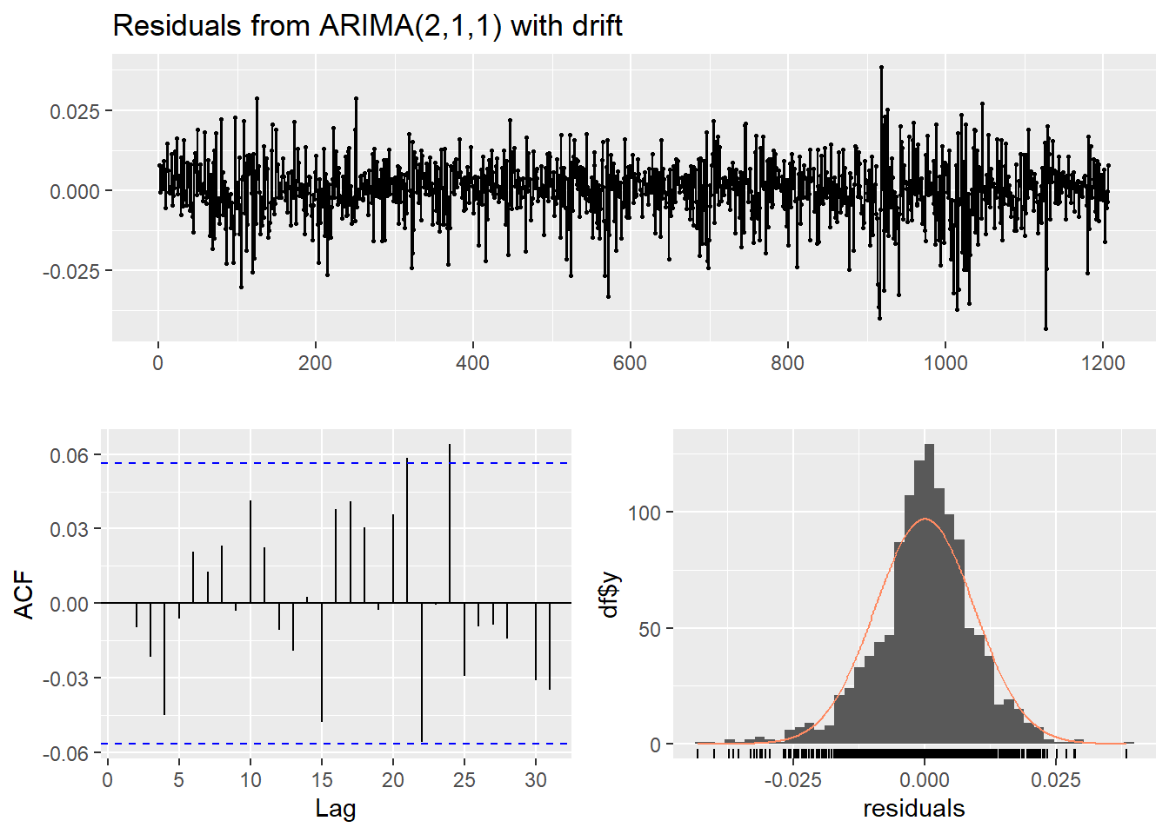

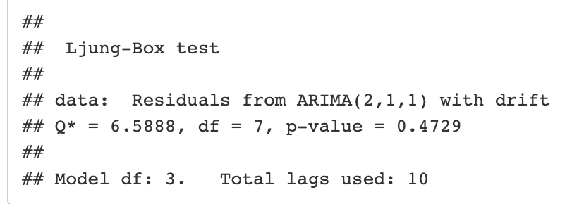

The model fitting statistics indicated an adequate fit. The Ljung-Box test yielded a p-value of 0.4729, indicating that we cannot reject the null hypothesis of no autocorrelation among the residuals, which suggests that our model effectively captures the temporal structures within the data.

However, upon evaluating the model's forecasting performance, the results were less encouraging. For the training set, the Mean Error (ME), Root Mean Squared Error (RMSE), and Mean Absolute Error (MAE) were all relatively low, indicating that the model did an excellent job in describing the historical data. The Mean Absolute Scaled Error (MASE) for the training set was also around 1, signifying that the model performed comparably to a naïve benchmark model.

However, the model's performance deteriorated on the test set. The RMSE and MAE were significantly higher than those for the training set, and the Mean Absolute Percentage Error (MAPE) was 0.7049, suggesting that the average forecast was off by about 70% in absolute terms. Moreover, the MASE exceeded 8 for the test set, indicating the model's performance was much worse than a naïve model.

The autocorrelation of residuals at lag 1 (ACF1) was close to 1 for the test set, indicating that there could be remaining patterns in the test set that the model failed to capture. Additionally, the high value of Theil's U on the test set implies that the model may not be better than a simple random walk model at making forecasts.

In conclusion, despite the satisfactory model fitting on the training data, the ARIMA model demonstrated limited success in forecasting unseen data. This suggests the need to revisit our model selection process, consider additional model types, or explore potential structural changes within the time series data that might have been overlooked.

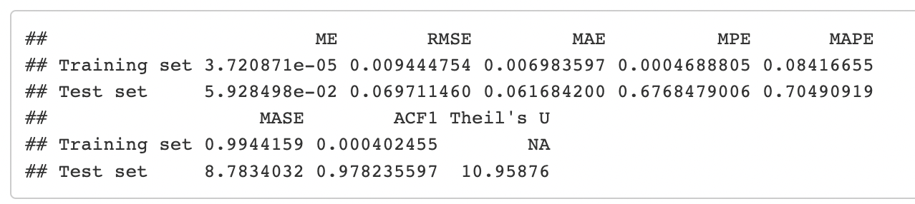

#### 4.1.1.2 ETS Model fitting results and analyses:

We chose ETS (M, N, N) as the fitted model based on data characteristics. An ETS (M, N, N) model is a time series model with multiplicative error, no trend, and no seasonality. It is suitable for time series data where the variation is proportional to the level of the series, but there is no discernible trend or seasonal pattern.

The data from 2012 to 2015 shows a consistent upward trajectory, albeit with some minor fluctuations. This suggests a growing trend, which is typical of many economic and business series, indicating increasing market demand or productive capacity.

However, a significant shift in trend dynamics is observed from 2015 onwards. Here, we begin to notice more substantial price fluctuations, indicative of market volatility. This could be due to various factors such as shifts in demand and supply, changes in market sentiment, or policy changes, among others.

Interestingly, the forecast made from 2017 onwards projects a steady, linear progression with no discernible incline, meaning the model doesn't anticipate any significant changes in the prices. The smooth, parallel price curve implies a forecast with a level trend, no seasonality, and constant variance over time. This may suggest an ETS (M, N, N) model or a similar non-trending model was used for the forecast, which expects prices to maintain an almost constant value.

In contrast, the actual test results from this period show a sharp upward trend, suggesting the forecast significantly underestimated the future prices. The steep 45-degree angle indicates a strong positive trend, suggesting substantial growth or inflation in prices.

Despite this discrepancy between the predicted and actual trends, it's important to note that both are within the confidence interval. This means that the actual outcomes still fell within the range of uncertainty accounted for in the forecast model.

While this doesn't necessarily indicate a faulty model, it does imply that the model may have lacked some key information or failed to capture certain trend components. The difference between the forecast and actual results might indicate a need for a more dynamic model that can better adapt to shifts in trends, especially in a context where prices can be influenced by numerous fluctuating external factors.

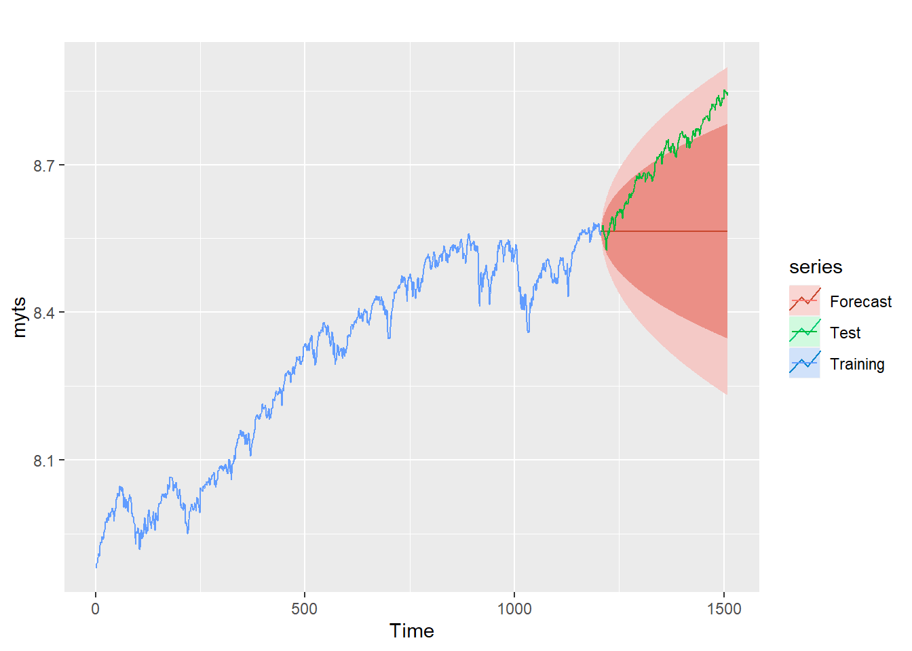

From the plot of residuals of ETS (M,N,N), it can be seen that all residuals fluctuate between ±0.025, with a few outliers, where the most off-zero outlier is around 0.0050. There is no obvious seasonality or periodicity detected in the image of residuals, it fluctuates irregularly. If the data were not collected or recorded correctly, this could result in outliers. Sometimes, extreme events (shocks) can cause outliers. For example, a natural disaster might dramatically impact sales for a short period of time. The ACF results show that most of the lags are within the critical value, and only a few lags exceed the critical value by a small amount, such as lag4 and lag22. We can consider this to be a white-noise data because of the no autocorrelation in its lags. Furthermore, the histogram shows a very clear pattern of a normal distribution. residuals walk within the curve of the normal distribution and basically coincide with the normal distribution curve.

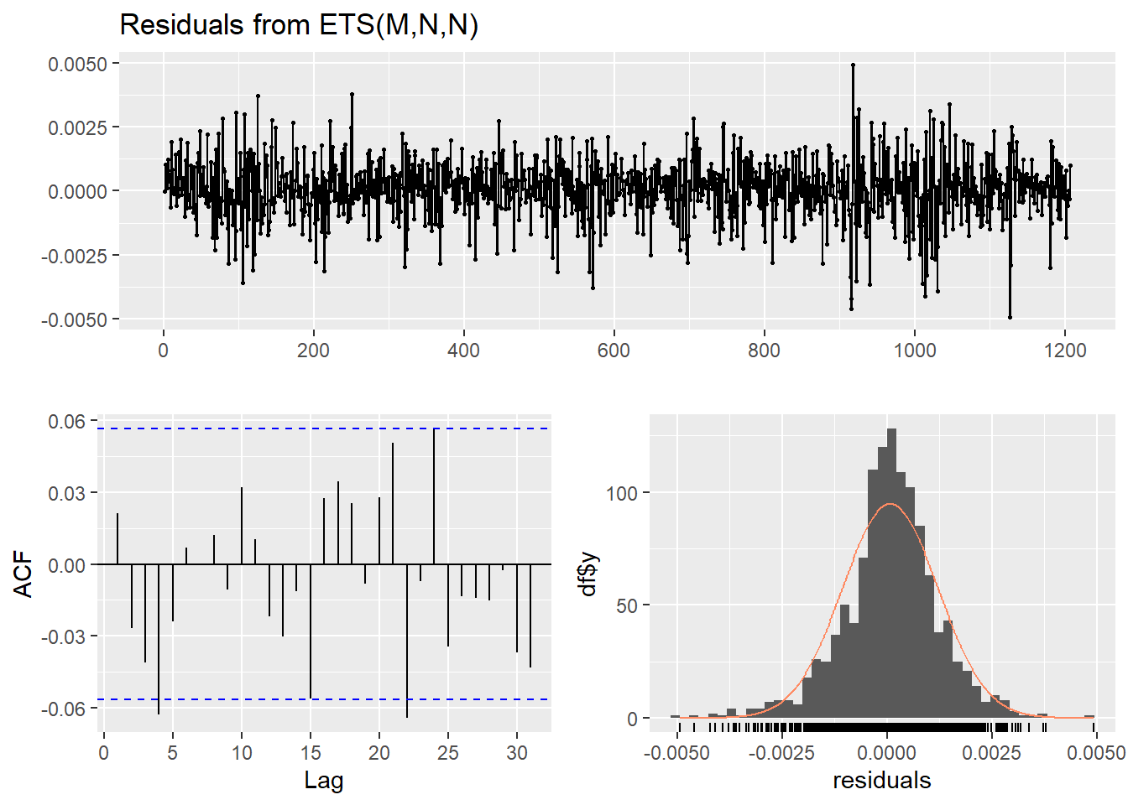

Q* = 10.604, and the null hypothesis of the Ljung-Box test is that the data are independently distributed. The larger the p-value, the more evidence we have to not reject the null hypothesis.

Since the p-value here is 0.3892 (above the typical significance level of 0.05), we would not reject the null hypothesis of independence among the residuals. This indicates that the residuals from the ETS (M, N, N) model are not significantly different from white noise, suggesting the model has appropriately captured the information in the series, and the residuals are just random fluctuations around zero.

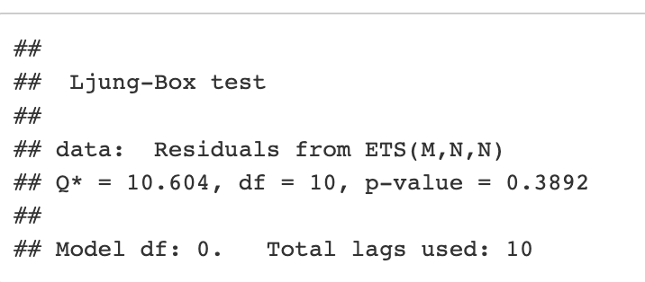

The model performance metrics indicate contrasting results for the training and test data sets. When applied to the training data, the model shows an excellent fit. This is evidenced by the low values of the ME, RMSE, MAE, MPE, and MAPE. All these metrics are near zero, signifying minimal discrepancies between the actual and forecasted values. Furthermore, the MASE value is close to 1, suggesting our model's performance is on par with a benchmark naive model. The Autocorrelation Function at Lag 1 (ACF1) value is relatively low, pointing to a lack of significant autocorrelation in the residuals, a desirable trait indicating the model has adequately captured the information in the series.

However, the forecast model's performance deteriorates considerably when applied to the test set. The high values of ME, RMSE, MAE, MPE, and MAPE indicate a significant degree of forecast error, implying that the model failed to accurately predict unseen data points. The MASE value is substantially larger than 1, indicating that our model performs worse than a naive model. In particular, the ACF1 value near 1 indicates strong autocorrelation in the residuals, suggesting that there is a pattern in the test data that our model failed to capture. Additionally, Theil's U statistic, a measure of forecast quality, is high, further demonstrating the model's poor predictive performance.

These findings suggest that while the model has effectively captured the patterns in the training data, it failed to generalize to unseen data in the test set. This discrepancy may be due to overfitting, where the model has become too specialized to the training data and is unable to accurately predict new, unseen data. Alternatively, the underlying pattern in the data may have changed in the test period in a way that the model failed to capture.

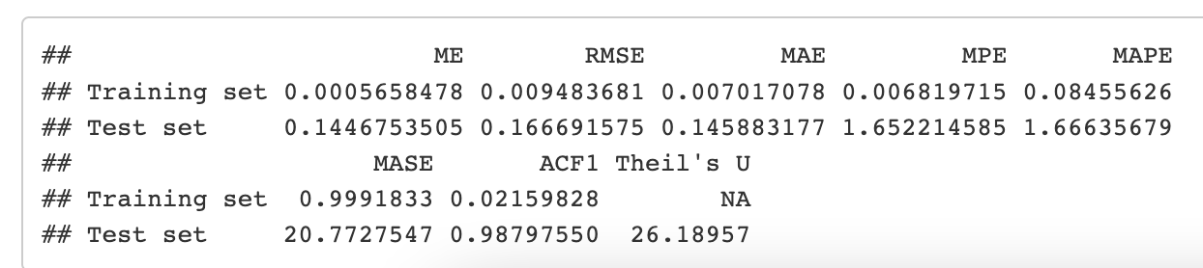

#### 4.1.1.3 Comparing the characteristics of the predicted data from both ARIMA and ETS models：

The comparison between the ARIMA (2, 1, 1) model and the ETS (M, N, N) model in terms of their performance on the given data set provides critical insights into the strengths and limitations of both models. Both models demonstrate a robust fit to the training data, effectively capturing the patterns within it, but exhibit poorer predictive performance on unseen test data. This could be indicative of overfitting or perhaps of a failure to capture some underlying structure in the data.

ARIMA models are popular in financial time series forecasting due to their ability to model data with non-constant variance and to capture a wide range of dynamic temporal structures. On the other hand, ETS models are simpler and offer more intuitive parameter interpretations. Yet, their restriction to multiplicative error, no trend, and no seasonality may limit their applicability in contexts where these factors are influential.

From a macroeconomic perspective, ARIMA models, by capturing autocorrelations and trends, may better handle economic variables that exhibit cyclical behavior or are impacted by policy changes. ETS models, meanwhile, might be more appropriate for stable, mature markets or sectors that do not show significant volatility or where changes are predominantly multiplicative.

Considering the stock market perspective, which is inherently volatile and influenced by numerous factors such as investor sentiment, macroeconomic indicators, and company-specific news, the ARIMA model's ability to model temporal dependencies can be beneficial. The observed trends and seasonality in financial markets make ARIMA a suitable choice for stock price predictions.

As per the economic situation's reality, the last decade has witnessed significant volatility due to events like the COVID-19 pandemic, various geopolitical tensions, and policy changes. Such events often lead to structural breaks in economic data, which could affect the performance of both ARIMA and ETS models. Therefore, it's essential to monitor such events and adjust the models accordingly.

When forecasting future economic conditions, consider the models' past performance but also factor in the changes in economic structures and policies. For instance, significant government stimulus or changes in interest rates can affect future stock prices and overall economic conditions, potentially requiring adjustments to the model.

In summary, while both ARIMA and ETS models have their strengths, their applicability and performance may vary based on the data characteristics and the context. Therefore, model selection should be guided by a comprehensive understanding of the underlying data and the specific forecasting context. Periodic model evaluations and adjustments are necessary to maintain their predictive accuracy over time. Additionally, incorporating external factors such as policy changes and major events can further enhance the models' performance.

### 4.1.2.DJI

#### 4.1.2.1. ARIMA

To make our predictions more accurate, we chose to set the frequency to 30, which means we take data once a month and record it as a new dataset for analysis and forecasting. Additionally, to evaluate the effectiveness of the predictions, we divided the data into a training set and a testing set. Here, we used the data before index 150 as the training set and the data after 150 as the testing set, as shown in the figure.

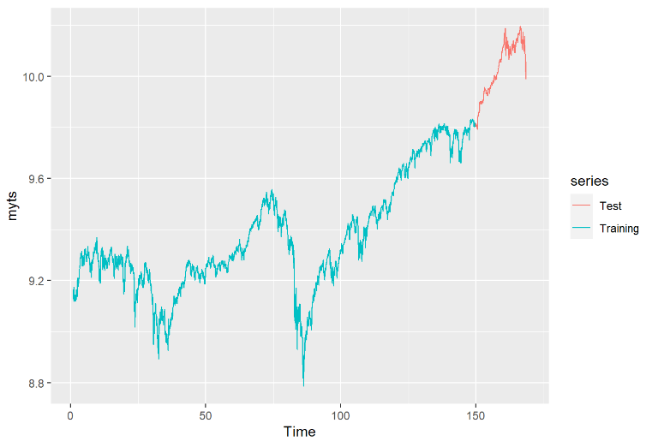

We used the AutoARIMA model to compare different ARIMA models and selected the model with the lowest AIC as the best fit model. Then, based on the fitted ARIMA model, we generated forecasts for the next 20 periods. The result of the auto-fitted model is ARIMA(2,1,0). The forecast for ARIMA(2,1,0) shows an upward trend with some fluctuations and peaks within both confidence intervals. According to the forecasted results, the data is expected to reach around 10.2 before time 200.

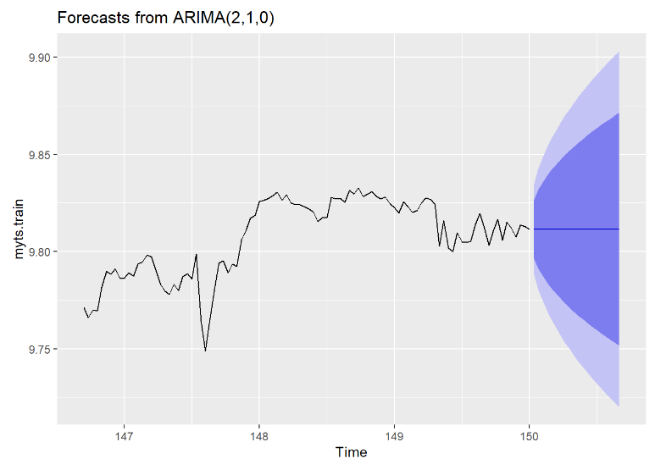

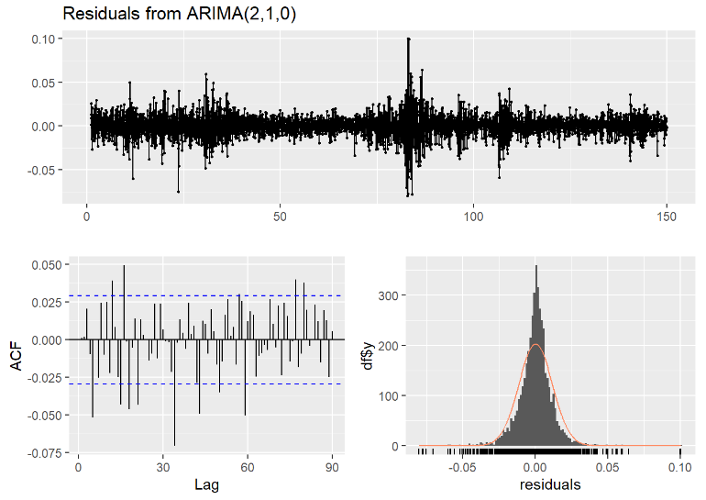

Analyzing the residual results: Firstly, looking at the distribution of the overall residuals, the values occasionally deviate from zero, but not exceeding ±0.1, which can be understood as the mean being approximately zero. Secondly, most of the lag values detected by ACF are within the confidence interval, with only a few exceeding the critical value, indicating the presence of some autocorrelation. From the histogram, it can be observed that it has a high degree of overlap with the normal distribution curve, suggesting that it appears to follow a normal distribution. Considering all three plots, we cannot accurately state that the residuals are white noise. However, in real-life scenarios, it is difficult to have residuals that strictly meet the conditions of white noise. Based on our analysis, the residuals obtained from fitting the ARIMA model approximate white noise, indicating a good fit of the model.

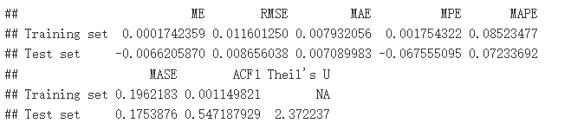

From the RMSE, MAE, MAPE, MASE, and Theil's U values, the model exhibits low error rates on the training data but high error rates on the test data. This may indicate the presence of overfitting issues introduced during the model selection and parameter tuning process. Additionally, the high ACF values on the test set indicate significant autocorrelation in the prediction errors, suggesting that the model may not have fully captured all the underlying patterns in the data. In conclusion, while the model seems to fit the training data well, there are some inevitable issues and room for improvement.

#### 4.1.2.2. ETS

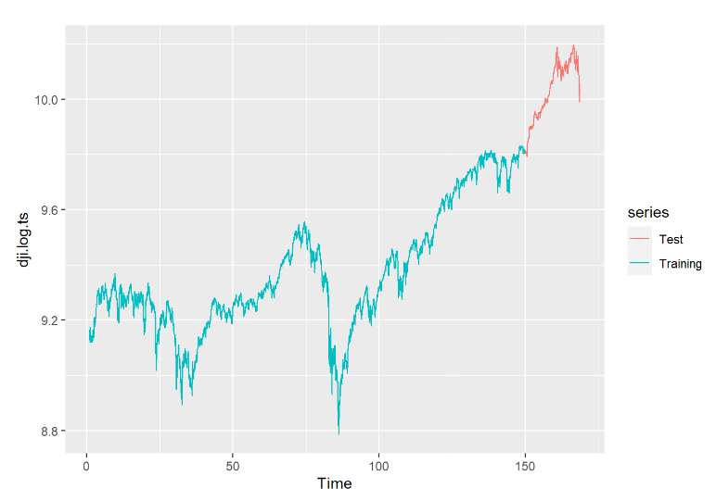Based on the data characteristics, ETS(A, N, N) was chosen as the fitting model. ETS(A, N, N) represents an additive model with no trend and no seasonality. This model assumes that the time series data is composed of a fixed level and does not exhibit any noticeable trend or seasonal variations. From the forecast results of ETS(A, N, N), it can be observed that the predictions beyond time 150 are very similar to the predictions of the ARIMA model. The peak value of 10.2 is reached before time 200.

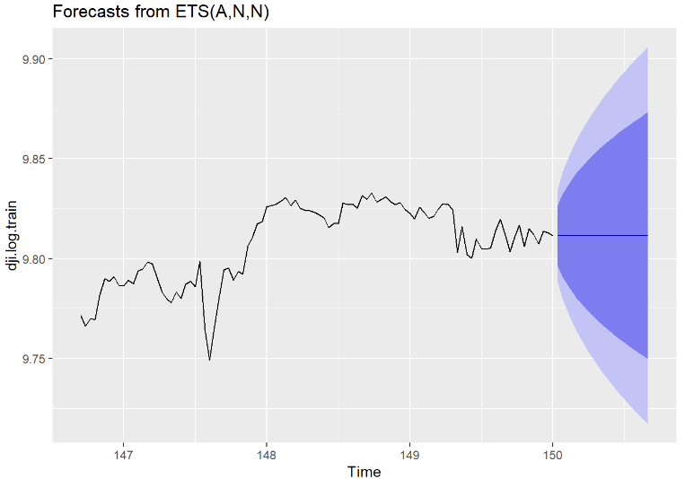

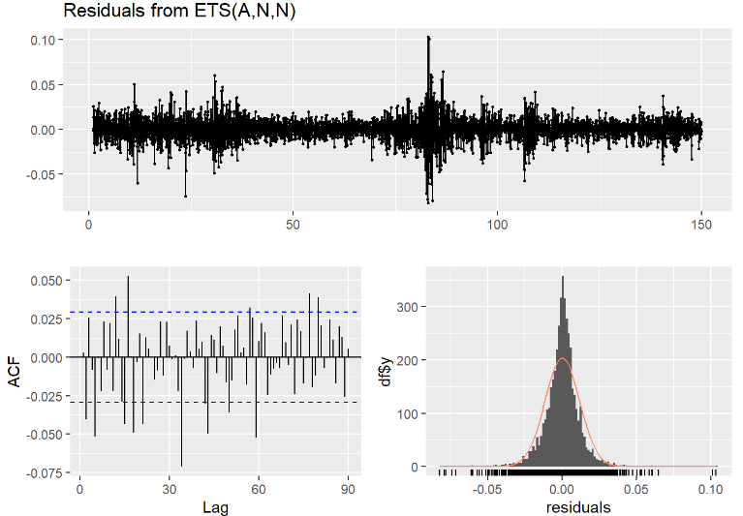

From the residual plot of ETS(A, N, N), it can be observed that all the residuals fluctuate within the range of ±0.1. There are some outliers around time 60, which may be attributed to extreme events such as black swan events that can lead to exceptional values. The residual plot does not exhibit any apparent seasonality or periodicity, showing irregular fluctuations. However, the mean is close to zero, and after excluding the outliers, the variance remains relatively constant. The ACF (Autocorrelation Function) results indicate that most of the lags are within the critical bounds, with only a few lags significantly exceeding the critical value, such as lag 32 showing a distinct negative correlation. Therefore, we can conclude that this is a non-white noise data, as it exhibits strong autocorrelation at certain lags. Additionally, the histogram displays a clear normal distribution pattern, although the tails do not fully encompass all the data points. Overall, the residuals align closely with the normal distribution curve.

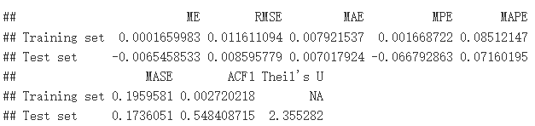

From the RMSE, MAE, MAPE, MASE, and Theil's U values, the model exhibits low error rates on the training data but higher error rates on the testing data. This could indicate that the model is overfitting the training data. However, the referenced error values are relatively small, indicating a good fit. In conclusion, although the model appears to fit the training data well, its performance on the testing data suggests that there may be room for improvement.

#### 4.1.2.3. Compare

To compare these two models, the most effective approach is to compare the evaluation metrics, namely RMSE, MAE, and MAPE values of the ARIMA and ETS models. Lower RMSE, MAE, and MAPE values indicate higher prediction accuracy. Firstly, if we only consider the RMSE on the training set, the ARIMA model has a slightly lower RMSE compared to the ETS model. However, in reality, the difference between them is very small and almost negligible. Therefore, the performance of these two models is very close. While both models provide valuable insights, their accuracy is crucial. Overfitting or underfitting can lead to inaccurate predictions, and in practical scenarios, overfitting can result in high costs. Hence, improving these models to enhance their predictive accuracy and make them better representatives of the underlying economic conditions should be the focus of optimizing the fitting models.

### 4.1.3.SPX500

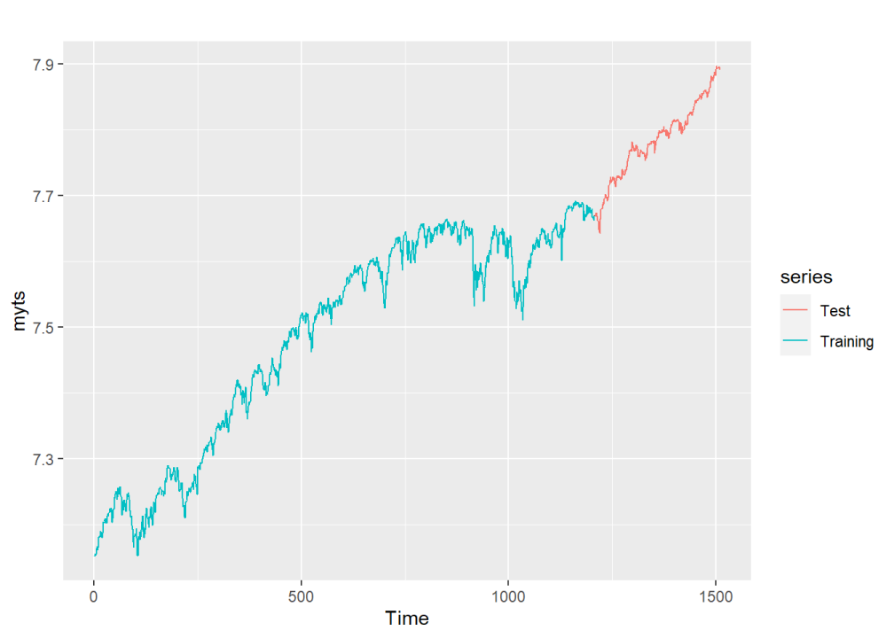

For the ARIMA model, we use the auto.arima function. As shown in the graph below, here is the ARIMA(2,1,1) model, which means that the parameters of the ARIMA model (p,d,q) is (2,1,1) at this time. To be more specific, the potential autoregressive orders (p) is 2, the potential moving average orders (q) is 1, and the one-time differencing operation before means d is 1.

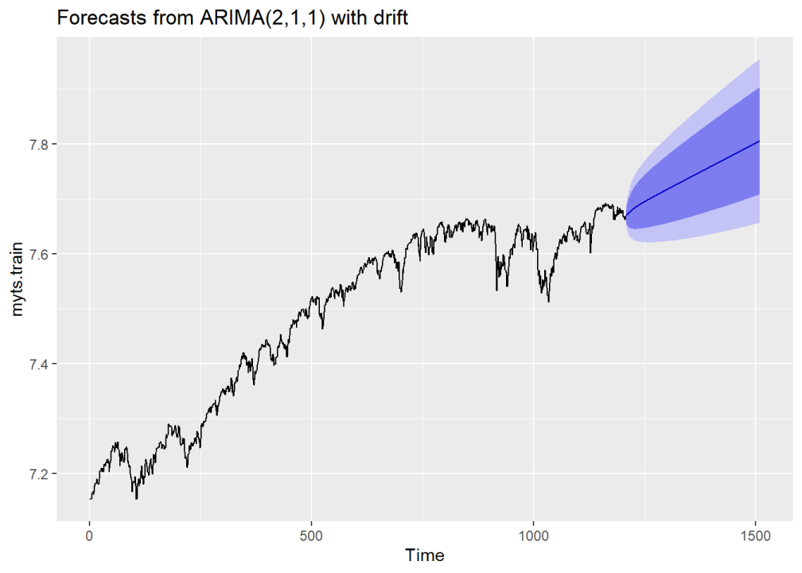

The graph below indicates that the forecast of the data by the ARIMA model is good with the test set, because the test set lies in the 80% confidence interval here.

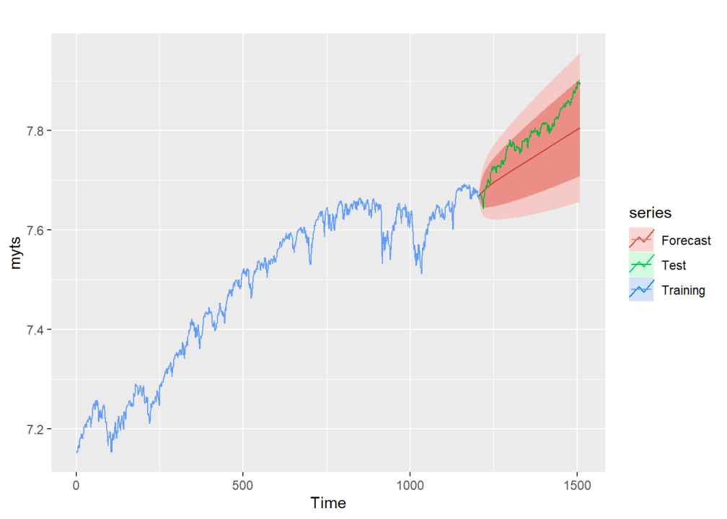

To test the extent and effect of this prediction through ARIMA model, we can also check residuals here. As shown in the figures, although there are some obvious fluctuations in the residuals, it is relatively average and stable on the whole. In ACF, although there is one autocorrelation lag out of the critical line, it is still like a white noise here. And the residuals also show approximately normal pattern. So for such a result, we can say that this is a relatively good prediction.

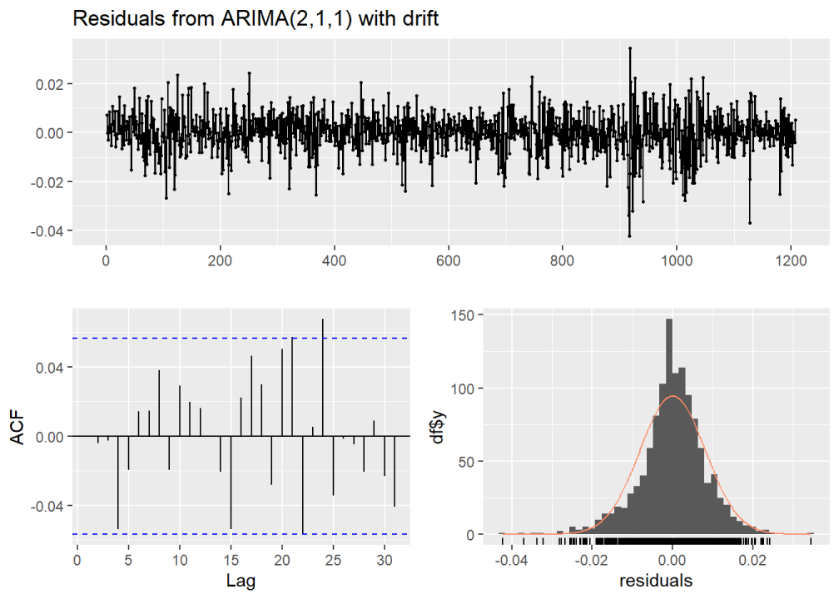

Then, we can also check its accuracy, that is, to evaluate it by some specific values. Here we can calculate several important values in evaluation metrics, in particular RMSE (Root Mean Squared Error), MAE (Mean Absolute Error), and MAPE (Mean Absolute Percentage Error). Since they all represent errors, the lower, the better. As we can see, the values of RMSE, MAE, and MAPE are very low for both the training set and the test set, indicating that the model is effectively minimizing the impact of large prediction errors. This shows that the prediction of this ARIMA model also still has certain feasibility and reliability from the analysis of RMSE and other values. Therefore, in summary, the fitting degree of this ARIMA model to the prediction of the future trend of SPX500 is relatively high and appropriate.

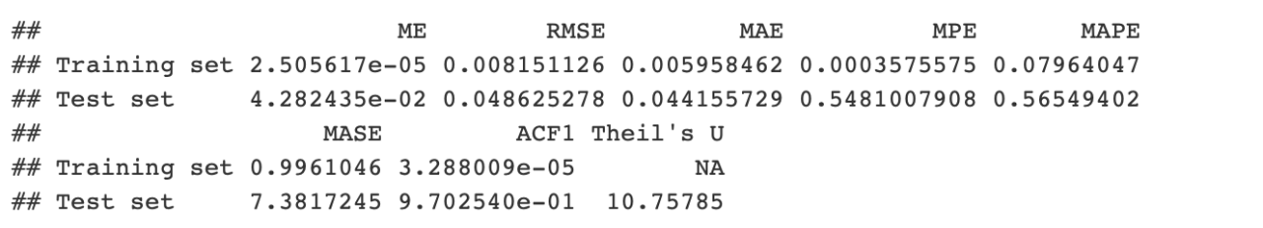

In addition to the ARIMA model, we can also use the ETS model to make a time series forecasting. Firstly, like ARIMA, we also use 80% and 20% to divide the data into training set and test set, as shown in the figure below.



Then we use ETS model to analyze and predict the training set. From the graphs below, the forecast of the data by the ETS model may not so good, because some of the test set data are out of the main range (80% confidence interval) of the prediction.

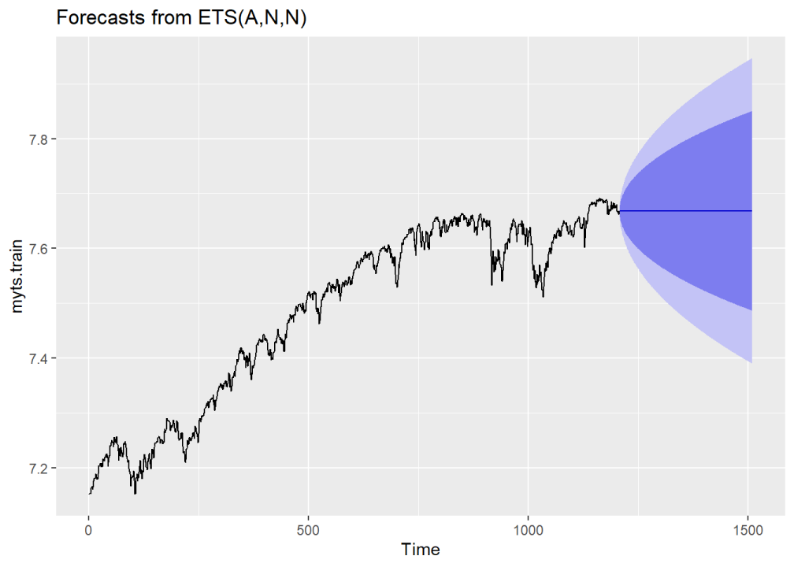

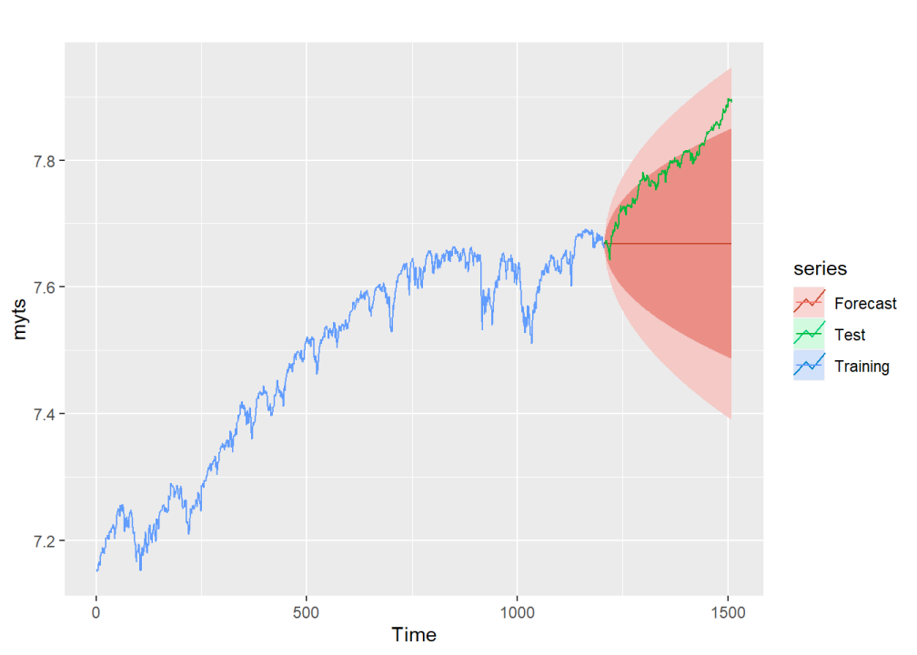

Similarly, in order to demonstrate the effectiveness and accuracy of this model, we also adopted the methods of check residuals and accuracy here. In the following figures, the whole residuals basically show a uniform trend, with several prominent fluctuations. And residuals seem relatively normal. But ACF is not a white noise, since there are several lags out the the critical line. So ETS model’s forecast of the data is feasible but not so good here.

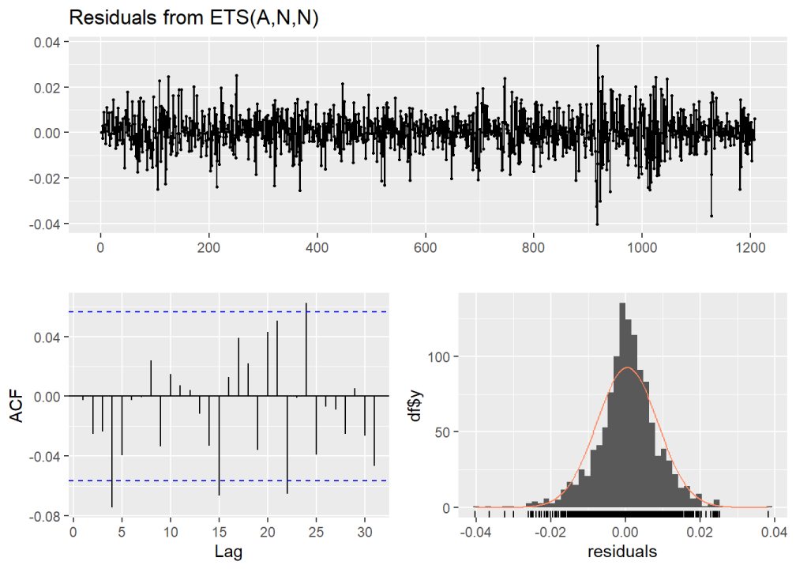

Moreover, in evaluation metrics below, some of the RMSE, MAE, and MAPE values are low, but some are not low enough. For example, some are lager than 1. So the effectiveness of the ETS model is not high enough here.

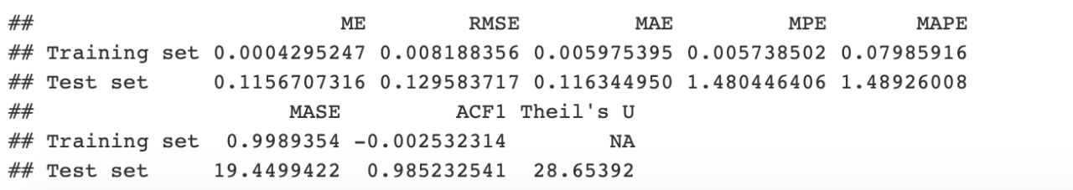

In conclusion, although both ARIMA model and ETS model can make reasonable and effective predictions on SPX500 data, we can also compare them to find the best model for forecasting SPX500 data. In order to compare the two models, the most efficient way is to compare the evaluation metrics, that is comparing the values of RMSE, MAE, and MAPE between the ARIMA and ETS models.  Lower values of RMSE, MAE, and MAPE indicate better forecasting accuracy. From the two evaluation metrics here, all of the RMSE, MAE, and MAPE, and all other values of ARIMA model are lower than that of ETS model. And although the differences between some of them are very small and almost identical, if we have to choose an optimal one, based on most values, the ARIMA model is probably better than the ETS model here.

## 4.2. The analysis of the Time Window

This report presents a comprehensive analysis on the impact of varying time window lengths, frequencies, and data averaging techniques on the performance of time series forecasting, specifically using the ARIMA model. The focus of our study is the S&P 500 index, which serves as a reliable indicator of the overall U.S. equity market performance.

The dataset used in our analysis spans from 2012 to 2017, a period rich in trends and fluctuations that lend themselves to time series analysis. To create a robust model and ensure a fair evaluation, the dataset has been partitioned into 80% for training and 20% for testing the ARIMA model.

The analysis is divided into three main aspects:

1.Impact of Time Window Length: The first part of our study concerns the influence of the length of the time window on the forecasting results. Two different time periods have been considered - the full period from 2012 to 2017, and a shorter one from 2014 to 2017. The ARIMA model's predictive power is examined for both these periods.

2.Impact of Time Window Frequency: The second part delves into the effects of data frequency. Three different frequencies - daily, weekly, and monthly - were analyzed using the full 2012-2017 dataset. The forecasts produced by the ARIMA model for each frequency were then compared.

3.Impact of Averaging: Lastly, the third part explores the influence of data averaging on the model's performance. Two weekly datasets from 2012 to 2017 were utilized - one created by selecting data every seven days and the other by averaging the data over each week.

By shedding light on these three aspects, this report seeks to enhance the understanding of how the choice of time window characteristics can influence the effectiveness of ARIMA-based time series forecasting in the context of equity market indices.

### 4.2.1. Impact of Time Window Length on Forecasting

#### 4.2.1.1Analysis of Five-Year Data (2012-2017)

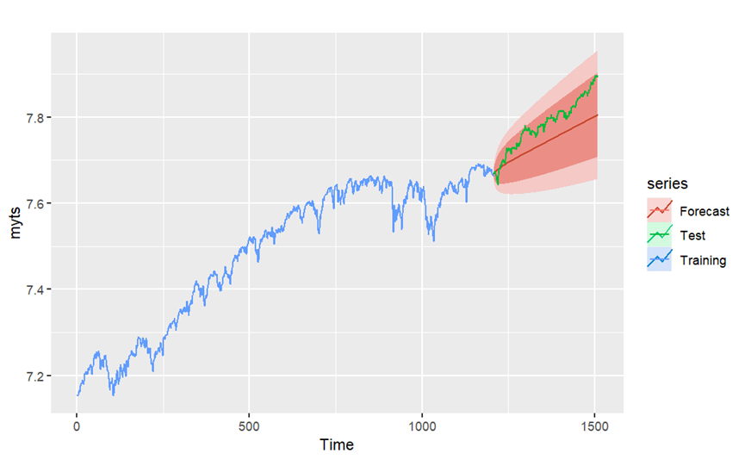

Utilizing the data from 2012 to 2017, the ARIMA(2,1,1) model was applied after running the auto. arima function.  The forecast graph successfully captured the trend of the test set.  Remarkably, the test set data was entirely within the 80% confidence interval of the forecast, indicating a relatively precise prediction. And the area of confidence interval is small. The small size of the confidence interval area and the fact that the test set remained within the interval can be interpreted as low forecast uncertainty.

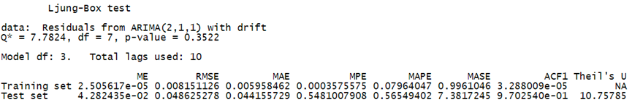

The Ljung-Box test resulted in a p-value of 0.3522, implying that the residuals are independent at all lags, and the model is well specified. In the Training set’s RMSE is only 0.008151 and the test set’s RMSE is 0.048625278

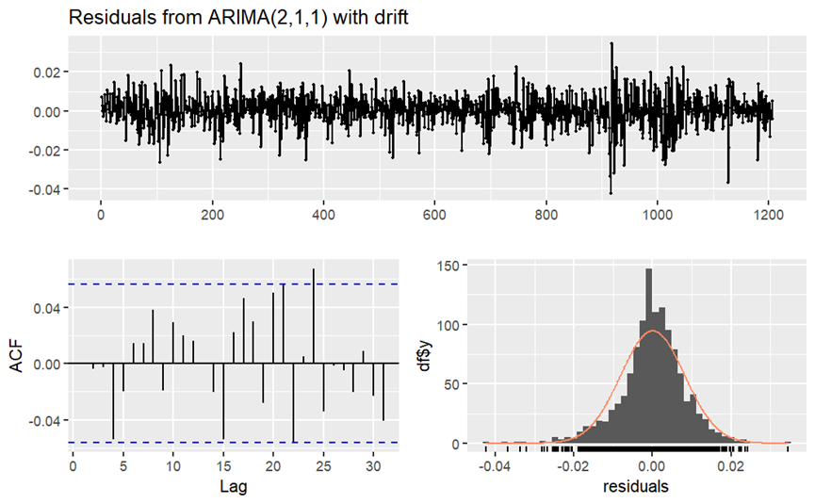

ACF plot analysis showed that apart from a minor exceedance at lag24, all other lags were within the critical value, which suggests that there is no autocorrelation in the residuals.  Furthermore, residuals exhibited a near-normal distribution, which supports the suitability of the model.

#### 4.2.1.2. Analysis of Three-Year Data (2014-2017)

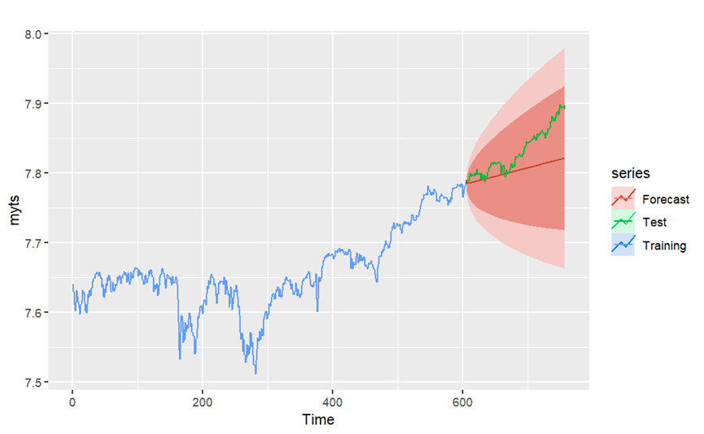

A different pattern was observed when analyzing the data from 2014 to 2017.  This time, the ARIMA(1,1,1) model was applied.  Although the 80% confidence interval still covered the entire test set, the forecast was less accurate compared to the five-year data, as indicated by the larger area of the confidence interval, suggesting higher forecast uncertainty.

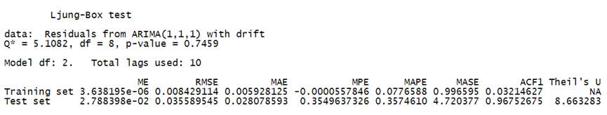

The Ljung-Box test gave a p-value of 0.7459, indicating that the residuals are independent at all lags, and the model is adequately specified. The test set RMSE performance is even better than 5 years data ,but the Training set’s RMSE is higher than 5 years which is 0.008429 indicating the underfitting.

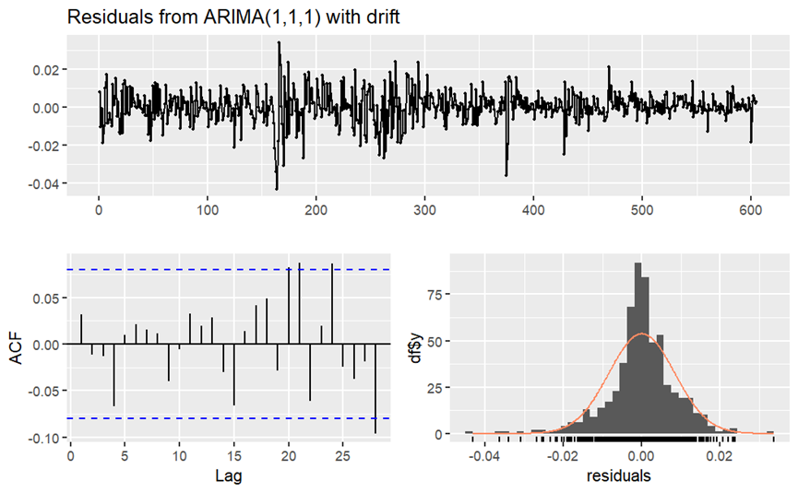

The ACF plot showed that at lags 21, 24, and 28, the values exceeded the critical value, indicating some level of autocorrelation in the residuals, which can be a potential issue.  Yet, the distribution of the residuals remained close to the normal distribution, suggesting that the model still provides a decent fit.

**4.2.1.3. Comparison and Conclusion**

In conclusion, our analysis demonstrates that the time window length significantly impacts the ARIMA model's predictive accuracy. In our specific case, a longer time window yielded better forecasting outcomes. This suggests that a longer historical record might provide more comprehensive information for the model to better understand the trend and cyclic patterns in the data.

However, it's crucial to note that in practical applications, extending the time window for your data can introduce more noise and potential outliers into your model, including unpredictable "black swan" events. These rare and severe occurrences can considerably affect market behavior, posing a challenge to forecasting models.

Moreover, an overly large dataset can also lead to prediction errors. It may incorporate more irrelevant or outdated information, thereby reducing the predictive power of the model. Furthermore, a larger dataset could span periods with different underlying market conditions. If market behavior changes over time, a model trained on an extensive historical dataset may not perform well in the current environment.

Therefore, while our analysis points to the benefits of a longer time window, it's essential to balance this against the potential risks and challenges. This includes the introduction of black swan events and shifts in market behavior that could impact the model's performance. Ultimately, the optimal time window length will depend on the specific characteristics of the dataset and the forecasting goals.

This underscores the importance of a comprehensive understanding of your data and the necessity of conducting robust sensitivity analyses. Such measures ensure the determination of the most suitable model and parameters for each specific forecasting task, offering more reliable and accurate predictions.

### 4.2.2.   Impact of Time Window Length on Forecasting

#### 4.2.2.1Analysis of Daily Data



Utilizing the data from 2012 to 2017, the ARIMA(2,1,1) model was applied after running the auto. arima function.  The forecast graph successfully captured the trend of the test set.  Remarkably, the test set data was entirely within the 80% confidence interval of the forecast, indicating a relatively precise prediction. And the area of confidence interval is small. The small size of the confidence interval area and the fact that the test set remained within the interval can be interpreted as low forecast uncertainty.



The Ljung-Box test resulted in a p-value of 0.3522, implying that the residuals are independent at all lags, and the model is well specified. In the Training set’s RMSE is only 0.008151 and the test set’s RMSE is 0.048625278



ACF plot analysis showed that apart from a minor exceedance at lag24, all other lags were within the critical value, which suggests that there is no autocorrelation in the residuals.  Furthermore, residuals exhibited a near-normal distribution, which supports the suitability of the model.

#### 4.2.2.2. Analysis of Weekly Data

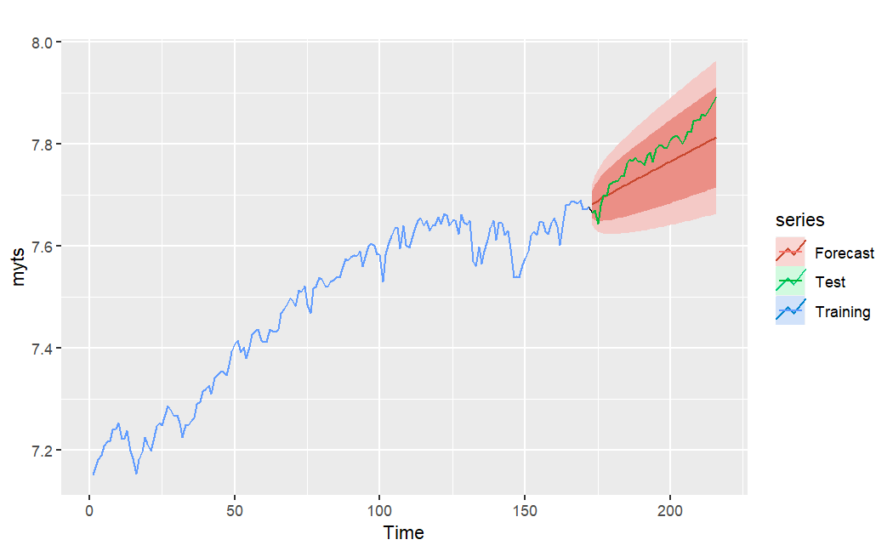

The predictive model begins by indicating values higher than the test parameter within this timeframe, adopting an approximate 30-degree slope. In subsequent forecasts, the predicted values drop below the test values. Nevertheless, the general trend remains consistent, and given that the projections fall within the confidence interval, these predictions can be deemed credible and reasonable.

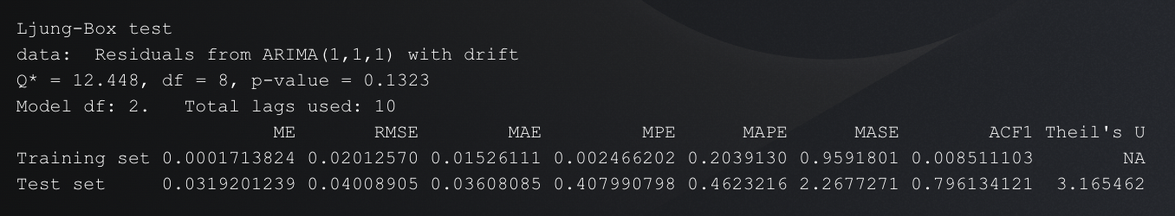

The test statistic Q* = 12.448, with degrees of freedom (df) = 8, yielding a p-value of 0.1323. The p-value is greater than the common significance level (0.05), suggesting that the null hypothesis cannot be rejected. This implies that the residuals are independently distributed, and there's no significant autocorrelation, indicating a good fit of the ARIMA model.

The 'Model df' is 2, which refers to the number of parameters in the ARIMA model, excluding the variance. The total lags used in this test is 10, which is typically chosen as a small multiple of the number of observations to the power 1/4.

Looking at the metrics for the training set: The ME is near zero, which implies that there is no persistent tendency for the forecasts to over- or under-forecast. The RMSE is quite small (0.02012570), indicating a model with good accuracy. The MAE is 0.01526111, which is low, showing that the model has minimal errors. The MPE and MAPE are also quite low, which suggests that the forecast errors, in percentage terms, are small. The MASE being less than 1 is also a good sign.

For the test set, the error metrics (ME, RMSE, MAE, MPE, MAPE, MASE) are higher than the training set, suggesting the model does not perform as well on unseen data as it does on the training set. This may be a sign of overfitting. A high Theil's U statistic (>1) indicates that the model's forecast is worse than a naive forecast, suggesting the model may need to be reassessed for its predictive power on future data.

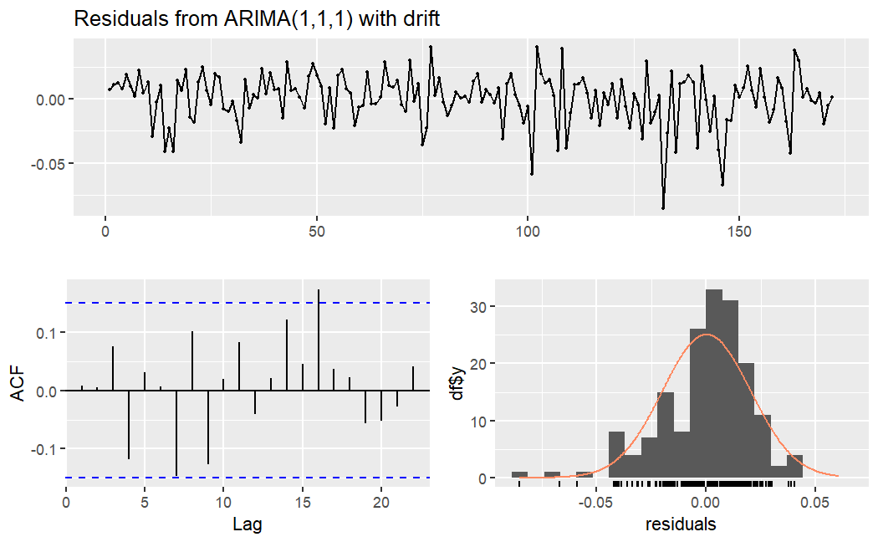

#### 4.2.2.3. Analysis of Monthly Data

### 4.2.3. Impact of Averaging

#### 4.2.3.1. without average



The predictive model begins by indicating values higher than the test parameter within this timeframe, adopting an approximate 30-degree slope. In subsequent forecasts, the predicted values drop below the test values. Nevertheless, the general trend remains consistent, and given that the projections fall within the confidence interval, these predictions can be deemed credible and reasonable.



The test statistic Q* = 12.448, with degrees of freedom (df) = 8, yielding a p-value of 0.1323. The p-value is greater than the common significance level (0.05), suggesting that the null hypothesis cannot be rejected. This implies that the residuals are independently distributed, and there's no significant autocorrelation, indicating a good fit of the ARIMA model.

The 'Model df' is 2, which refers to the number of parameters in the ARIMA model, excluding the variance. The total lags used in this test is 10, which is typically chosen as a small multiple of the number of observations to the power 1/4.

Looking at the metrics for the training set: The ME is near zero, which implies that there is no persistent tendency for the forecasts to over- or under-forecast. The RMSE is quite small (0.02012570), indicating a model with good accuracy. The MAE is 0.01526111, which is low, showing that the model has minimal errors. The MPE and MAPE are also quite low, which suggests that the forecast errors, in percentage terms, are small. The MASE being less than 1 is also a good sign.

For the test set, the error metrics (ME, RMSE, MAE, MPE, MAPE, MASE) are higher than the training set, suggesting the model does not perform as well on unseen data as it does on the training set. This may be a sign of overfitting. A high Theil's U statistic (>1) indicates that the model's forecast is worse than a naive forecast, suggesting the model may need to be reassessed for its predictive power on future data.



Test set     0.0319201239 0.04008905 0.03608085 0.407990798 0.4623216 2.2677271 0.796134121  3.165462

**3.2 with average**

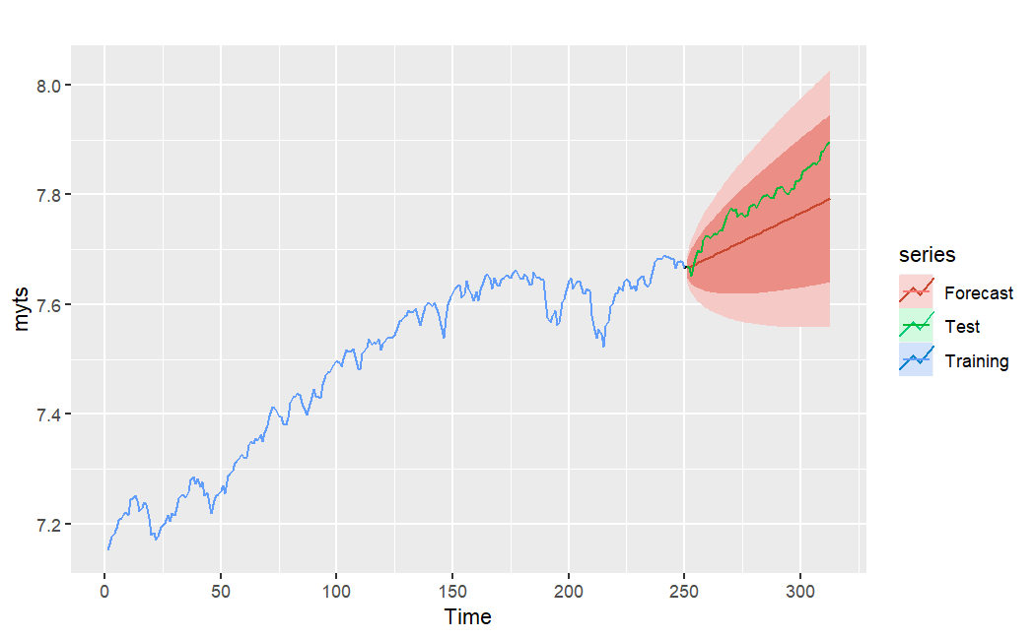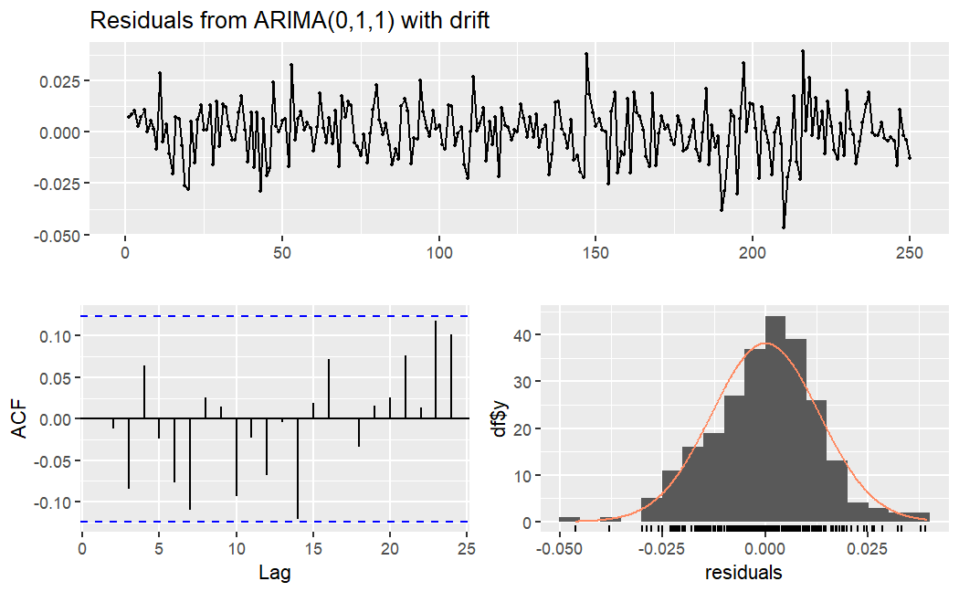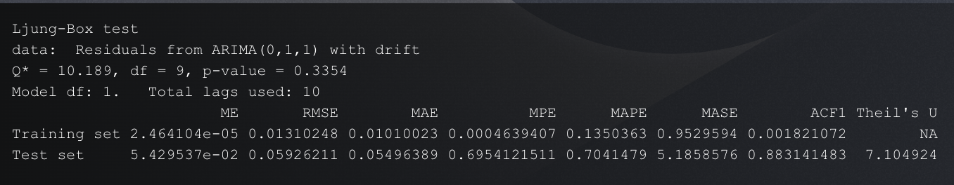

#### 4.2.3.3 comparison and conclusion

# 5. Discussion

## 5.1 Interpretation of Findings

## 5.2 Comparison of the ETS Model and ARIMA Model

# 6. Recommendations

# 7. Conclusion

# Reference

Yahoo Finance. (2023, July 17). S&P 500 Index (^GSPC) Stock Price, News, Quote & History. Retrieved July 17, 2023, from <https://finance.yahoo.com/quote/%5EGSPC/>

Yahoo Finance. (2023, July 17). Dow Jones Industrial Average (^DJI) Stock Price, News, Quote & History. Retrieved July 17, 2023, from <https://finance.yahoo.com/quote/%5EDJI?p=%5EDJI>

Yahoo Finance. (2023, July 17). NASDAQ Composite (^IXIC) Stock Price, News, Quote & History. Retrieved July 17, 2023, from https://finance.yahoo.com/quote/%5EIXIC

# Appendices

## Code_1

#following code use python to grab the stock index data from Yahoo Finance

import pandas as pd

import yfinance as yf

start_date = "2012-01-01"

end_date = "2017-12-31"

spx=yf.download('^GSPC',start=start_date, end=end_date)

data=spx.reset_index()

three_years_data = data[data['Date'] > data['Date'].max() - pd.DateOffset(years=3)]

two_years_data = data[data['Date'] > data['Date'].max() - pd.DateOffset(years=2)]

freq_seven_data = data.iloc[::7, :]

freq_seven_mean_data = data.resample('7D', on='Date').mean()

freq_30_data = data.resample('30D', on='Date').mean()

five_years_data = data

three_years_data.to_csv('process/SPX_3years.csv')

two_years_data.to_csv('process/SPX_2years.csv')

freq_seven_data.to_csv('process/SPX_freq7.csv')

freq_seven_mean_data.to_csv('process/SPX_freq7_mean.csv')

five_years_data.to_csv('process/SPX_5years.csv')

freq_30_data.to_csv('process/SPX_freq30.csv')

NASDAQ=yf.download('^IXIC', start=start_date, end=end_date)

DJI=yf.download('DJI', start=start_date, end=end_date)

NASDAQ.to_csv('data/NASDAQ.csv')

DJI.to_csv('data/DJIA.csv')

spx.to_csv('data/SPX.csv')

## Code_2

#following code use R and the data from code_1 to generate plot

library(fpp2)

library(rmarkdown)

library(itsmr)

library(readr)

DJIA<-read_csv("data/DJIA.csv")

SS_1<-read_csv("data/000001ss.csv")

NASDAQ<-read_csv("data/NASDAQ.csv")

SZ399001<-read_csv("data/399001sz.csv")

DJIA.ts <- ts(DJIA[,"Close"])

ss.ts<-ts(SS_1[,"Close"])

na.ts<-ts(NASDAQ[,"Close"])

sz.ts<-ts(SZ399001[,"Close"])

DJIA.tsd<-ts(DJIA[,"Close"]-DJIA[,"Open"])

DJIA.return<-ts((DJIA[,"Close"]-DJIA[,"Open"])/DJIA[,"Open"])

ss.tsd<-ts(SS_1[,"Close"]-SS_1[,"Open"])

ss.return<-ts((SS_1[,"Close"]-SS_1[,"Open"])/SS_1[,"Open"])

na.tsd<-ts(NASDAQ[,"Close"]-NASDAQ[,"Open"])

na.return<-ts((NASDAQ[,"Close"]-NASDAQ[,"Open"])/NASDAQ[,"Open"])

sz.tsd<-ts(SZ399001[,"Close"]-SZ399001[,"Open"])

sz.return<-ts((SZ399001[,"Close"]-SZ399001[,"Open"])/SZ399001[,"Open"])

autoplot(DJIA.ts)

autoplot(DJIA.tsd)

autoplot(DJIA.return)

test(DJIA.ts)

test(DJIA.tsd)

test(DJIA.return)

autoplot(ss.ts)

autoplot(ss.tsd)

autoplot(ss.return)

test(ss.ts)

test(ss.tsd)

test(ss.return)

autoplot(na.ts)

autoplot(na.tsd)

autoplot(na.return)

test(na.ts)

test(na.tsd)

test(na.return)

autoplot(sz.ts)

autoplot(sz.tsd)

autoplot(sz.return)

test(sz.ts)

test(sz.tsd)

test(sz.return)